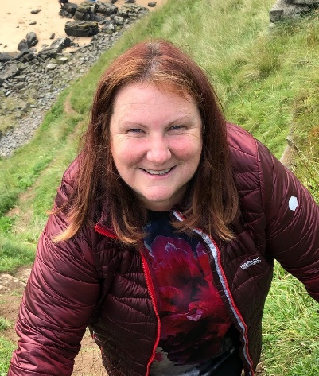
Hi my name is Gail Agar and I’m currently the Chair and Secretary of the Parent Council. I am currently a full time mum to a 6 year old in Boddam School.
I originally went along to my first meeting just to see what it was all about. I was extremely surprised to find out how much the Parent Council fundraising pays for within the school and the extent to which the school uses us a sounding board for decisions within the school. Even taking on two roles within the council I don’t find it takes up much of my time and I’ve met a good bunch of mum’s and dad’s through the events we have been allowed to run since I joined.
I would encourage anyone who is interested just to come along to a meeting and see what it’s all about – you won’t have to come back if you don’t want to and you don’t need to commit to anything.
If you don’t want to come to a meeting you can always approach any of us if you see us either at the school gate or in the village and we’ll try to help you or bring the question to the school. Otherwise you can always get in touch with us at boddamparentcouncil@yahoo.co.uk.

