Boddam School
Online Learning Policy
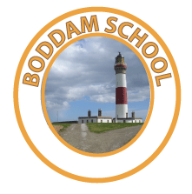

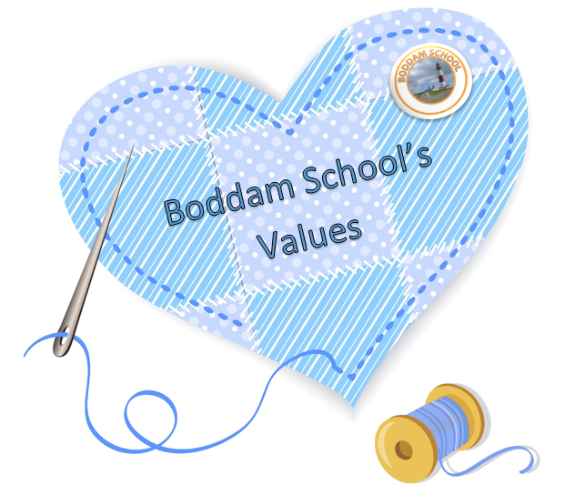
Teamwork
Honesty
Respect
Equity
Aspirations
Determination

Boddam School
Online Learning Policy – January 2021
Rationale
During situations when access to the school building is not possible for an extended period such as, severe weather, power shortages or a pandemic, it is important that we at Boddam School prepare to look after the wellbeing of our school community and support our families and pupils to continue learning.
We want to ensure that our pupils and families feel supported in their mental health in challenging times and that learning continues at an appropriate pace and challenge which is accessible to all.
We are using Google classroom through Glow for safety reasons as it has been developed and configured with safeguarding, child protection and information security as being primary considerations.
Google Classroom
This learning platform is especially important in ensuring greater equity and increased choice for our children during a school closure. The learning portal is also used for homework tasks for children from P2 – P7 and will be a way of sharing successes and achievements across the curriculum on children’s individual Google Classroom accounts.
Parents and pupils are asked to sign a consent form to enable teachers to deliver remote teaching into the home. The permission form outlines the agreed expectations, roles and responsibilities of the School, Parents and Pupils so that online learning can be carried out safely for everyone.
Children can access this learning portal through the web address below:
https://sts.platform.rmunify.com/account/signin/glow
Once on the site, children can type their own personal Glow email and password given to them from the school office. From here, they will be able to access Google Classroom and open homework tasks, access files, see curricular areas and celebrate achievements with parents/carers at home.
If in the event of a school closure only, teachers can use video-conferencing through the approved Glow infrastructure of Google Classroom. This will enable teachers and staff the opportunity to engage, face-to-face, with pupils and in so doing, support their needs. If the school is closed, then the link for video conferencing will be enabled along with the chat feature for children to use.
Role of Parents
We recognise that children can feel unsettled when not able to attend school in unusual circumstances. While teachers aim to continue to support learning, parents will know what their children are able to focus on during a given day. We actively encourage families to read, garden, bake, watch TV, play games together. Whilst, we also thank parents for their commitment to their children’s learning, allowing them to work independently for bursts is also helpful so we know what they can do on their own.
Communication
Google Classroom is a children’s learning portal and all parental communications with the school and staff will remain through the normal school channels. Parents may contact that school through Xpressions or email when the school is closed. Children can message their teachers in Google classroom through the class stream or privately to the teacher directly.
The Head Teacher or Principal Teacher will call families on a regular basis to check all is well and provide support where possible. In times of school closure this will be through Skype so the school number may not be recognisable.
As when the school is open, parents are asked to let the school know if children are unwell at any time.
Support Available
In addition to the School office, the school’s Facebook page has a list of guides to support the use of Google classroom. These can be found on the ‘Boddam School Learning’ site once Parents have signed and been approved by the Head Teacher. This is a closed site to Parents/Carers of children attending Boddam Primary School.
These can also be located on the Aberdeenshire Boddam school website page.

Online learning in Nursery
At Boddam E.L.C.C (Early Learning and Child Care) we follow the Curriculum for Excellence and during your child’s time with us, they will have the opportunity to participate in a range of challenging and enjoyable learning experiences in order to become successful learners, confident individuals, responsible citizens and effective contributors. Regular observations will be made of your child’s learning whilst they are taking part in these learning experiences, and next steps created for your child to work towards.
My Profile
Your child’s learning experiences and their magical learning journey at Boddam E.L.C.C is shared with you from the very first day in a format of a ‘Profile’ found on Google Classroom. As a team we make observations on your child’s development and learning and record these in your child’s profile. Photographs of your child may also be attached to your child’s observations along with photographs of their work to give you an insight of your child’s time and their day with us.
My Achievements
We celebrate each child as an individual within the nursery and are delighted to share their nursery journey and special moments using an ‘achievement’ folder found in their profile. When a child has achieved or progressed and taken the next step within their learning these times are celebrated and shared with you using ‘Ask Me About’ notes for you to also enjoy and share the child’s moment together at home.
Children’s Evaluations
The nursery team value each child’s voice and listen to each child as they are supported to lead their own learning within the nursery. Staff encourage each child to evaluate activities using a ‘thumbs up’ approach when they feel they have learned, progressed or simply enjoyed an activity for the first time. These special moments are captured under the ‘Children’s Evaluation’ folder in your child’s profile.
My Target
Each child throughout their time in nursery will be set a target which will be individual and unique to them. In areas where staff have made an observation, targets are created for your child to work towards. In order to inform you of your child’s target and to develop the home/nursery partnership these are posted under the heading ‘Targets’. Sharing these targets means staff can work closely with all parents so children can reach their full potential throughout their nursery time.
Family Challenges
Throughout your child’s time at Boddam E.L.C.C staff will support and encourage children to take part in the ‘Class Family Learning Challenges’. These challenges are posted on the ‘Stream’ section on Google Classroom each term. The challenges are fun and enjoyable for all the family to take part in at home and will support your child’s communication and language. The daily tips for playful learning at home are used to encourage children to play and talk together whilst having lots of fun!
Who is Google Classroom for?
Staff: The profile system will enable staff to record your child’s progress and share developments and achievements throughout the year and at times of transition.
Parents: As partners in your child’s education, we value your input to this profile. Please log in and look at your child’s journey and activities they are exploring.
Child: This is a profile that puts the child at the centre of their learning. They will be involved in contributing to the content with staff creating observations alongside your child.

Updated | Review Date | Version
January 2021 | January 2022 | 2021.01

