Boddam School
Handwriting Policy
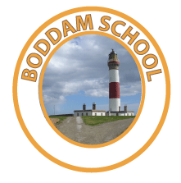

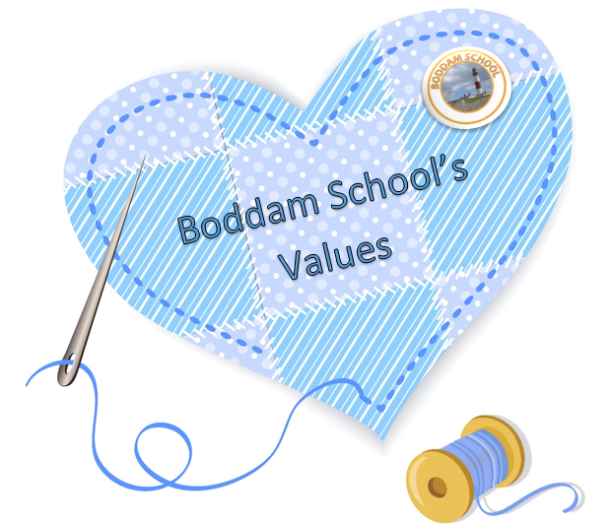
Teamwork
Honesty
Respect
Equity
Aspirations
Determination

Boddam School
Handwriting Policy - March 2021
Rationale
Our policy is in place to ensure that the teaching of cursive handwriting is a progression from mark-making to formal cursive handwriting. Children will be supported to communicate their needs and thoughts, and to present their work, in a way that is legible, effortless and will engage the reader.
Our policy also strives to ensure that children are taught handwriting at the correct developmental stages in a way which minimises confusion for them. Appropriate activities are delivered based on assessments and teacher judgement so that children can be adequately supported.
Assessment
Assessment in the nursery is ongoing and children are given many opportunities for mark-making and activities to develop fine motor skills. The Highland Literacy Pre-writing skills assessment tool is useful in identifying what stage the children are at and what the focus might need to be for individuals.
The development of these skills should be passed on to the P1 teacher at transition times. The P1 teacher may also carry out an assessment using the same tool when the children have been in school for a period. This assessment will dictate readiness for formal writing and the P1 teacher will plan a programme of fine motor skills activities in preparation for starting writing.
Children in the nursery setting who display a want and readiness for handwriting, will be provided with experiences which expose them to the pre-cursive letter formation which they will be more formally introduced to in P1. Parents can be provided with this information as well in an attempt to combat children picking up bad habits at an early stage.
Children who have not reached the stage of readiness may need extra support to develop their Fine Motor Skills and may become part of an FMS group.

Involving Parents
When children are in nursery, the development of FMS and the purpose of mark-making should be explained during a curricular learning event. Parents will be advised that formal writing will not be taught other than support given to those who demonstrate a readiness and motivation.
At transition to P1, the formation of pre-cursive letters and the reasoning behind why we support the teaching of cursive handwriting will be explained to parents during a P1 workshop. A booklet will also be given to parents to take home as a way of helping them to support their child with the correct formation of letters.
Resources
- Highland Literacy Emerging Literacy assessment for pre-writing skills
- Highland Literacy Emerging Literacy activities for Pre-writing and Fine Motor Skills
- Teach by example worksheets
- Handwriting jotters from P1 upwards when ready. Two sizes available – wide-ruled and narrow-ruled. It is thought that the wide-ruled should be used for P2 and P3 and narrow from P4 to P7 for most.

Practical Items
Care needs to be taken with the teaching of the following letters so that joining handwriting is consistent across the school (See Appendix 1):
- The lower-case letter f. This should be taught with an ascender and a descender, where it is looped up with an ascender and looped down with a descender in one continuous motion. Please see example attached.
- The lower-case j, g and y. They should all be taught with a descender, where they join to other letters via a descending loop. Please see example attached.
- The lower-case letter k. This should be taught with a curl / loop. Please see example attached.
- The lower-case x receives its second diagonal cross once the word is completed – similar to how you would if you were going back and crossing a lower case t.
- Children should be taught formal writing with a sharpened pencil, correct posture and pen-hold. This pen-hold should be encouraged form a very early stage in nursery. In P1, Stabilo EasyGraph pencils will be purchased for each pupil to aid correct pen-hold. These are available for right and left-handed children.
- Children at the early level will often use a felt tip pen in the early stages of mark-making and developing writing as it flows better.
- Children should only use a handwriting pen when the teacher feels they are ready to do so.
- Joined handwriting should be taught on a daily basis alongside the curriculum of spelling and writing challenges

Capital Letters
Capital letters are grouped into 3 sets and all letters start at the top:
- One stroke letters: C, O, L, S, U, V, W, Z
- Two stroke letters: B, D, G, J, K, M, N, P, Q, R, T, X, Y
- Three stroke letters: A, E, F, H, I
I, which will be taught with three strokes and J which will be taught with two strokes.
Capital letters are stand-alone letters and do not join to anything.
Lower case letters
- All letters get taught initially with an ‘entry flick’ and an ‘exit flick’ for subsequent joining. All lower case letters join. When the teaching of joined handwriting starts, children are told to dot i & j and cross t & x after the word is complete.
- All letters start from their ‘entry flick’.

Adult Responsibility
- Where possible, wall displays should have cursive titles/supporting information
- Teachers should model pre-cursive/cursive writing on whiteboard/Smartboard
- Feedback given to children should be written in pre-cursive/cursive script

Progression

It must be noted that the below should only be used as a guide. Some children will be ready earlier or later than others.

Early Level

Nursery

- Activities aimed at developing fine motor skills
- Mark making
- Highland Literacy Pre-Writing skills assessment
- Support provided to children and parents of those who display a readiness to write

P1

- Activities aimed at developing fine motor skills continued
- Mark making opportunities continued
- Highland Literacy Pre-Writing skills assessment performed again
- Fine motor skills group established for those that need more targeted support
- Some activities used to consolidate and further practise fine motor development
- All children provided with Stabilo EasyGraph pencil (right or left handed)
- Pre-cursive lower case letter formation introduced (in school and homework)
- Formal handwriting will begin in the early stage half way through term 1.
- Upper case letter formation introduced in term 4; supported by activities
- A line through mistakes will be encouraged to show progression

First Level

- Fine motor skills support available for those that still require it
- Stabilo EasyGraph pencil still available for those that need, Staedtler Noris 119 Tripus jumbo provided for those that are secure with their pen-hold
- Focus to remain on correct pre-cursive lower case and upper-case letter formation
- A combination of practice sheets to consolidate formation of letters will be used
- Joining can be taught in term 1 for those that display readiness with the support of activities
- Joined up writing to be formally taught daily
- Correct upper-case letter formation continued
- Wide-ruled handwriting jotters to be provided to children
- Teaching of joined up writing and upper-case letter formation to continue
- Narrow-ruled handwriting jotters to be provided to children that are ready

Second Level

- Teaching of joined up writing and upper-case letter formation to continue on at least a weekly basis
- Narrow-ruled handwriting jotters to continue to be used as appropriate
- Children encouraged to produce legible, neat, tidy and accurate handwriting in all pieces of work

Appendix 1

